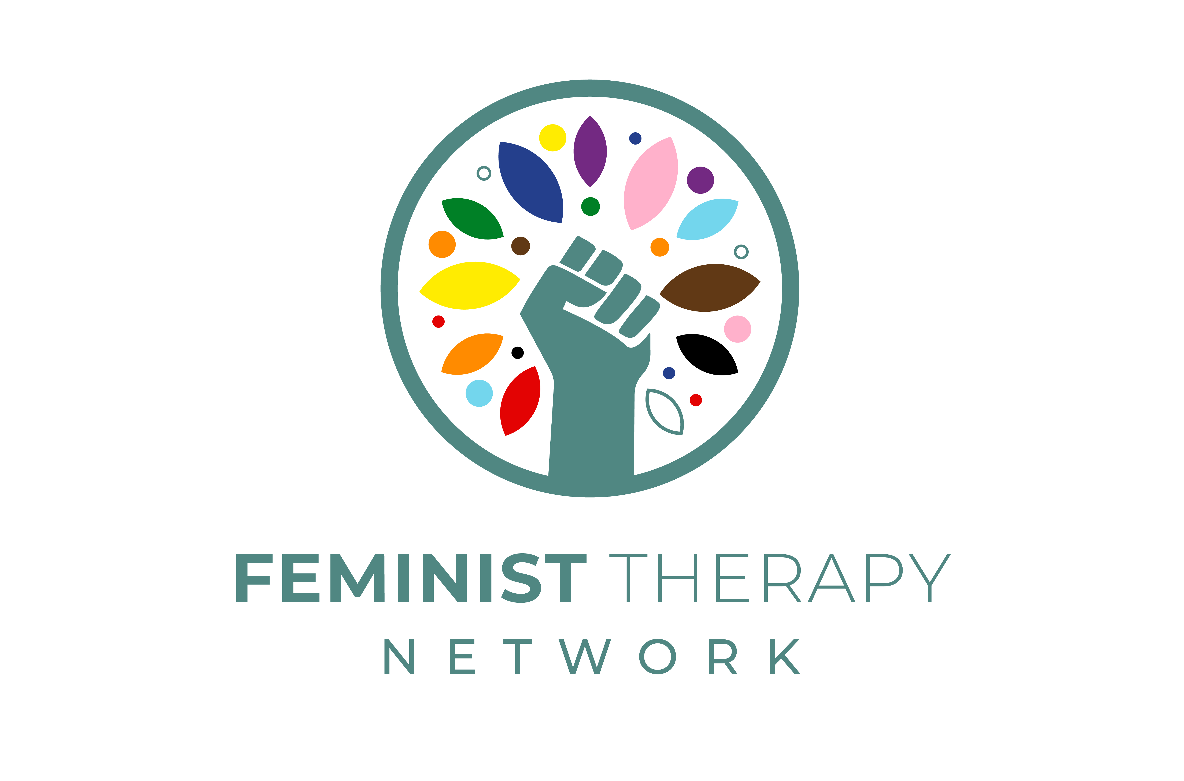

Perspectives in Feminist Therapy

A ten-session course starting in November 2025
25 hour CPD

This introductory course considers the early pioneers of feminist therapy and radical therapy movements, feminist therapy as a theoretical orientation, gender role analysis in the context of therapy, elements of a feminist conceptualization, feminist critiques of diagnosis, the relation between feminist therapy and social justice work, feminist therapy ethics and values and considerations for a contemporary feminist therapeutics. We will discuss writings and contributions from the broad spectrum of feminist scholarship and activism, including Black feminism, radical feminism, socialist feminism, eco-feminism, trans-feminism and politics of spirit feminism. This course is suitable for those training and working in the psy-disciplines, or a related field, with an interest in feminist therapies. Participants will complete the course with a rich and robust foundational knowledge in feminist therapies and their applications, as well as extensive resources to support continued learning upon completion.

The course will run online via Zoom over ten 2.5 hour sessions on Wednesdays 6.30pm – 9pm GMT. A 25-hour CPD Certificate of Completion will be provided at the end of the course.

The course will be facilitated by Rebecca Esho Greenslade (she/her). Formatively trained in existential psychotherapy, Rebecca has been working as a psychotherapist for the past fifteen years. Her therapeutic experience ranges from working in schools, in community practices at St. Joseph’s Hospice and The Psychosis Therapy Project, alongside running a private practice. She founded Gaia Therapy Project in 2018 – a community therapy project at Hackney City Farm, which has now transitioned to Gaia Therapy Collective. She is the founder of the Feminist Therapy Network. Rebecca has worked as a training supervisor and course tutor at The Minster Center, London and facilitates Feminist Therapy Supervision-Reading Groups. Her writings explore the interstices between embodied philosophy, psychotherapy, spirituality and liberatory feminisms and she is currently undertaking PhD research with the Department of Psychosocial Studies at Birkbeck, University of London that considers how a spiritualised feminist psychotherapeutics can intervene in contemporary modes of alienation. Rebecca is a Zen practitioner in the White Plum lineage and Buddhist chaplain. She lives in London and Charlottesville. www.rebeccagreenslade.org

Fees: Standard rate: £300.00 Solidarity rate: (support the FTN): £300.00 - £350.00
Sponsored rate: £150.00 (two spaces available)

Dates: The course runs online over ten 2.5 hour sessions on Wednesdays 6.30 – 9.00pm GMT.
Start Date: 12th November 2025 End Date: 4th February 2026
The course will run in two five-week cycles, with a three-week break over the winter holidays.
Course dates: 12th, 19th, 26th November 2025, 3rd & 10th December 2025, 7th, 14th, 21st, 28th January 2026, 4th February 2026
Please do check the course dates before applying – it is hoped you will be able to attend all or most of our sessions together. For the group’s cohesion, please do ensure that you are able to attend the first evening of the course on 12th November 2025, which will include introductions and agreeing our principles for a feminist classroom. Sessions will not be recorded.

Apply: Please complete and return the application form below to feministtherapynetwork@protonmail.com by Wednesday 1st October 2025. Upon acceptance, full and non-refundable payment will be due by Monday October 13th 2025.

Personal and contact details

Name
Pronouns
Email
Phone number
Location

Please outline your training and experience as a therapist or therapist in training.

Please describe your relationship to feminist theory and practice (if at all).

What are your hopes and intentions for the course?

Do you have any concerns or questions?

Participation & Pedagogy

This is not a didactic course. We will be learning together in the age old traditions of communal learning, cultivating collective wisdom, building solidarities and engaging the feminist imagination. To do so, requires a commitment to each other. To support our community of inquiry and to share the labour of learning together, the request is for Zoom screens to be on during our time together. Please ensure you will be able to join and participate from a stable physical place (not in transit). You will be asked to read and be prepared to discuss one longer or two shorter readings / podcasts / videos each week. It is also recommended that you keep a reflective journal throughout the course.

Please share if you anticipate the culture of learning described above may pose challenges for you and the kind of support you might need to enable and nurture your participation.

Are you applying for sponsored place? If you are, please detail the difference a reduced fee will make to you.

Feminist Therapy Network Ethos

The FTN ethos is rooted in practicing trans-inclusive and intersectional feminisms and learning and unlearning the colonial legacies that maintain oppressive practices within therapy. Our learning space together will be both cultivated and held by this ethos. Please confirm that you have read the FTN Ethos and agree to participate in accordance with this.

Confirmation

I confirm the information given on this form is correct to the best of my knowledge.

Signed |  | Date

Thank you for your application!

